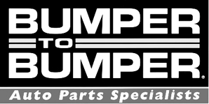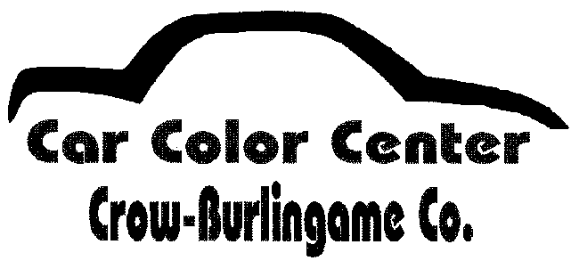

**Collision Repair/ Refinishing Competition**

**Consumables Provided:**

StickIt Sanding Paper Various Grits – 6”DA, File Board, Sanding Block.

Body Filler

Spreaders, Mixing Boards, Stir Sticks and Mixing Cups

Welding Panels

Fenders for Repairing and Panels for Painting

3M PPS Cups 2.0 for paint spray gun. These use the 2.0 style gun adapters, not provided.

Sealer / Color Coat / Clear Coat

Latex Gloves

Paper Towels and Tac Cloths

Plastic Repair Products

**Items NOT Provided:**

Personal Protection – Working Gloves, Welding Hood, Safety Glasses, Respirators, Dust Mask

Tools – DA Sander, Backing Pads, Files, Hand Tools (hammer / dollies), High Flo Fittings for Air Tools,

Paint Spray Guns

**Equipment Provided:**

Estimating Computers w/Estimating Software

Welders

AIR Compressor

Paint Booth